

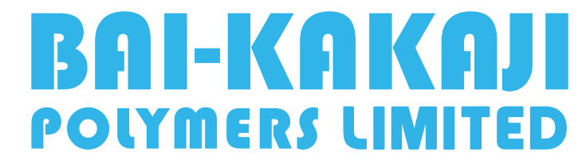

ARCHIVAL POLICY

ARCHIVAL POLICY

BACKGROUND
The Securities and Exchange Board of India (“SEBI”), vide its Notification dated September 2, 2015, has issued the SEBI (Listing Obligations and Disclosure Requirements) Regulations, 2015 (“Listing Regulations”). The Regulations come into force from December 1, 2015. The Regulations mandate listed entities to formulate an archival policy.
OBJECTIVE OF THE POLICY
In terms of Regulation 30(8) Listing Regulations, BAI-KAKAJI POLYMERS LIMITED (“Company”) is required to discloses on its website all such events or information which has been disclosed to stock exchange where the securities of the Company are listed under Regulation 30 of Listing Regulations. Further, such disclosures shall be hosted on the website of the Company for a minimum period of 5 years and thereafter as per the archival policy of the Company, as disclosed on its website. Accordingly, the Company has framed this policy duly adopted by the Board of Directors of the Company.
The objective of this Policy is to disseminate equal, adequate and timely information to the shareholders through the website of the Company and to enable them to track the performance of the Company over regular intervals of time and provide sufficient information to enable investors to assess the current status of the Company.

SCOPE
The documents, information, disclosures, notices, policies as provided under the Listing Regulations and the Companies Act, 2013 (“Act”), which is required to be disclosed on the website, shall be uploaded on the website of the Company. The website of the Company shall be reviewed on regular intervals for ensuring that all the above mentioned disclosures are available on the website of the Company as required. These disclosures, unless otherwise mentioned in the Act itself, shall be hosted on the website for the five years period and thereafter shall be moved/ transferred to Archives folders under the respective heads/ sub-folders, in a way so that these can be searched easily as and when required by any person. The documents/ disclosure shall be kept in the archive folders till such time as may be required by law.
AMENDMENT
Any change in the Policy shall be approved by the Board of the Company. The Board shall have the right to withdraw and/ or amend any part of this Policy or the entire Policy, at any time, as it deems fit, or from time to time, and the decision of the Board in this respect shall be final and binding.
In case any provisions of the Policy are contrary to or inconsistent with the provisions of the Companies Act, 2013, rules framed thereunder and Listing Regulations (“Statutory Provisions”), the provisions of Statutory Provisions shall prevail.
DISSEMINATION OF THE POLICY
The policy shall be hosted on the website of the Company i.e. https://www.baikakajipolymers.com

*************
Effective Date: May 23, 2025
Date of Approval by Board of Directors: May 23, 2025

